CREATE TABLE employees (

employee_id NUMBER PRIMARY KEY,

first_name VARCHAR2(50),

last_name VARCHAR2(50),

department_id NUMBER

);

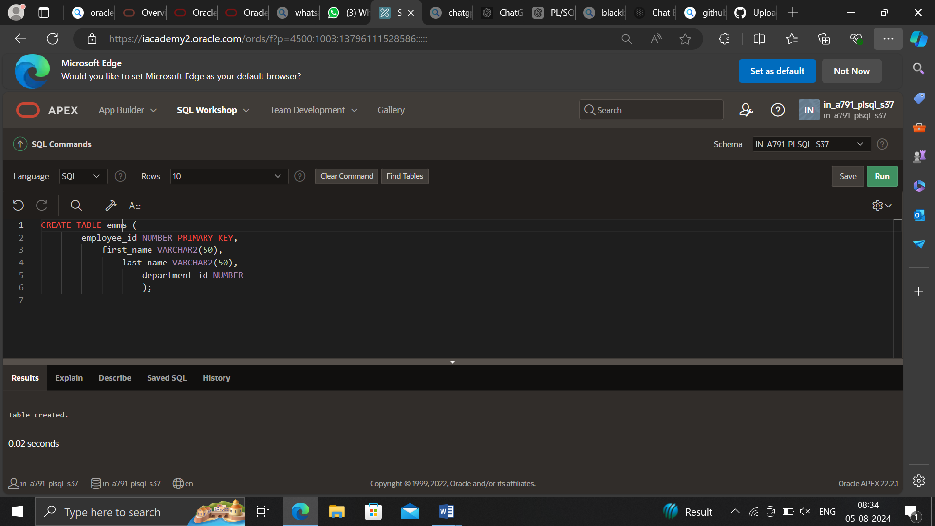

CREATE TABLE departments (

department_id NUMBER PRIMARY KEY,

department_name VARCHAR2(50)

);

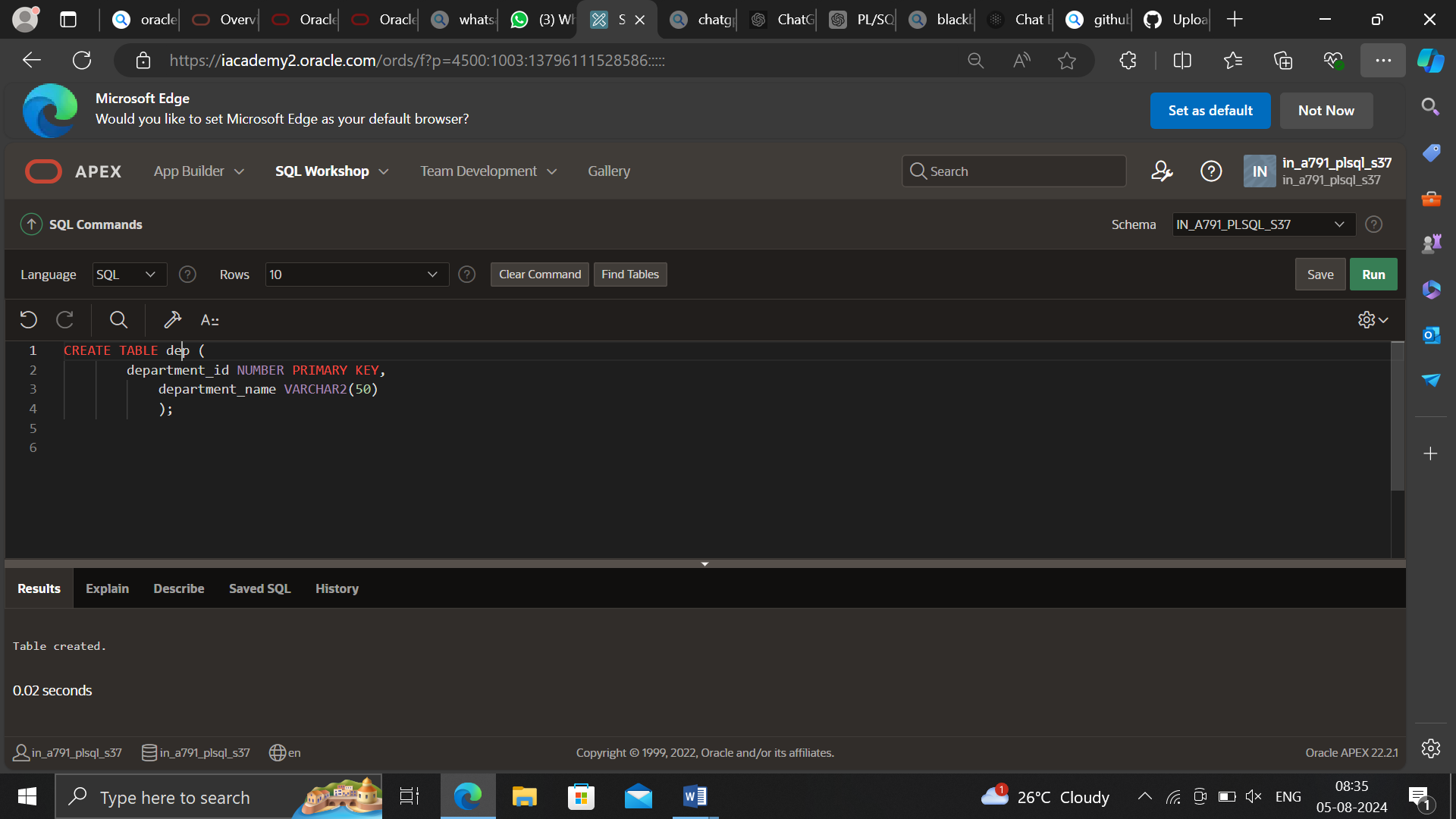

INSERT INTO employees (employee_id, first_name, last_name, department_id) VALUES (200, 'John', 'Doe', 10);

INSERT INTO employees (employee_id, first_name, last_name, department_id) VALUES (201, 'Jane', 'Smith', 20);

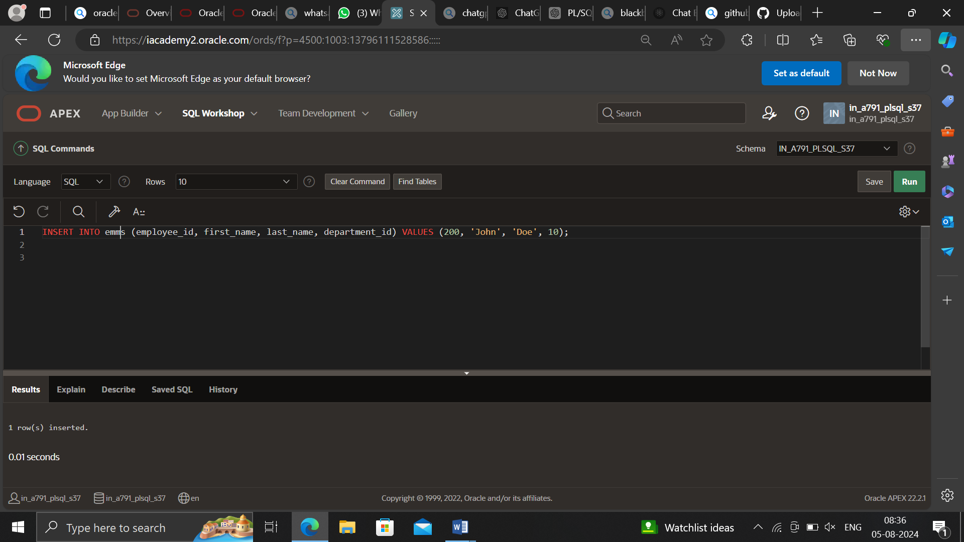

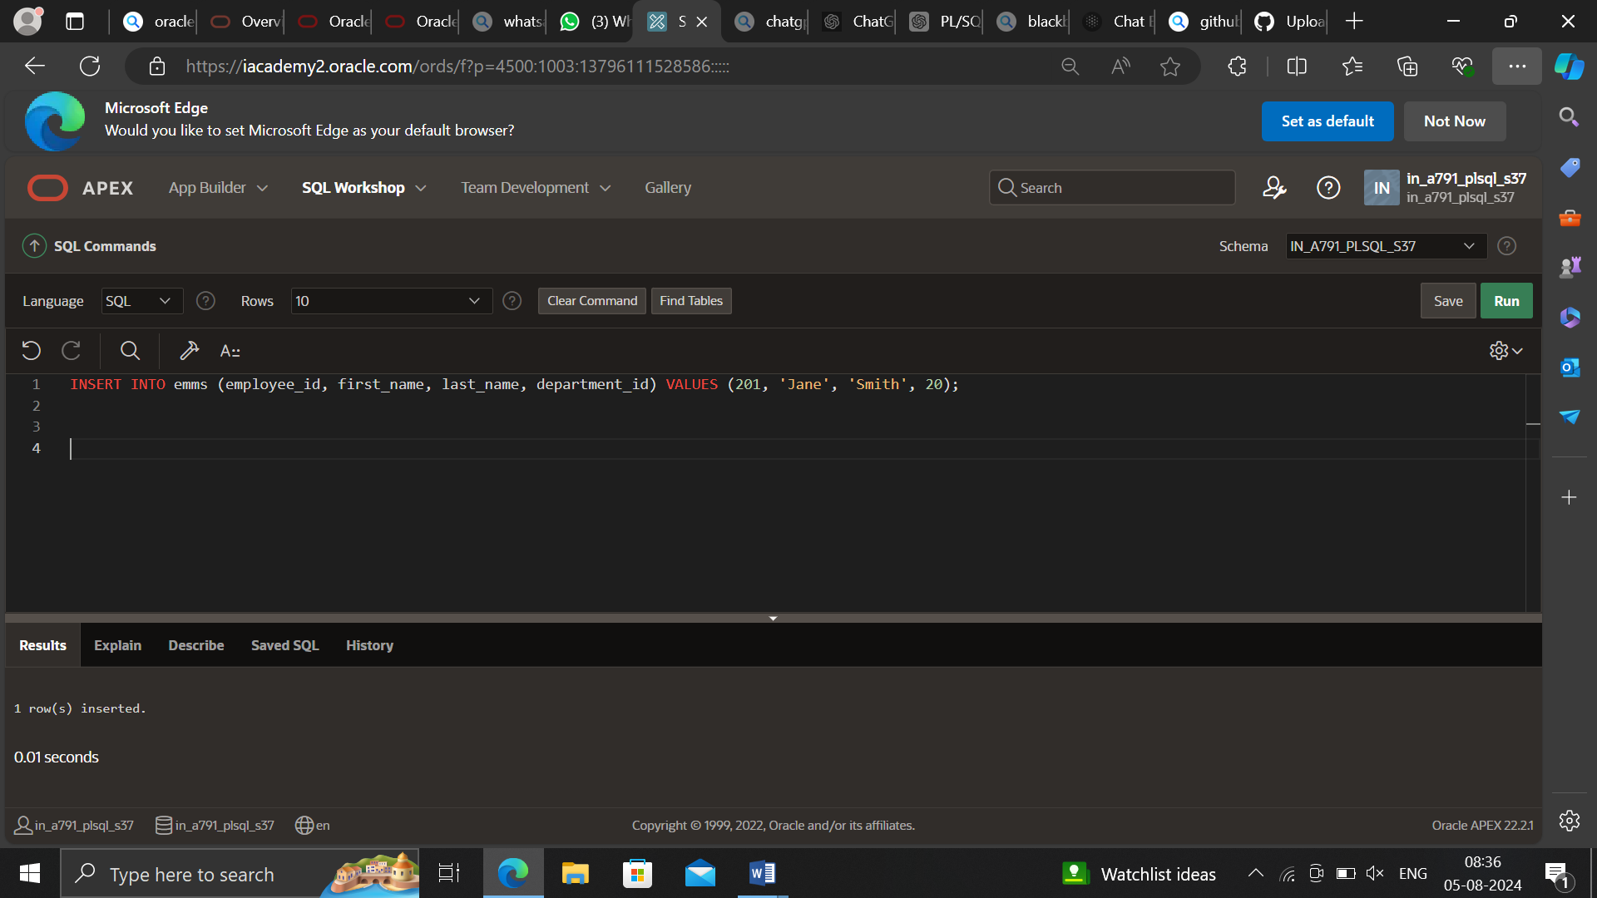

INSERT INTO departments (department_id, department_name) VALUES (10, 'HR');

INSERT INTO departments (department_id, department_name) VALUES (20, 'Finance');

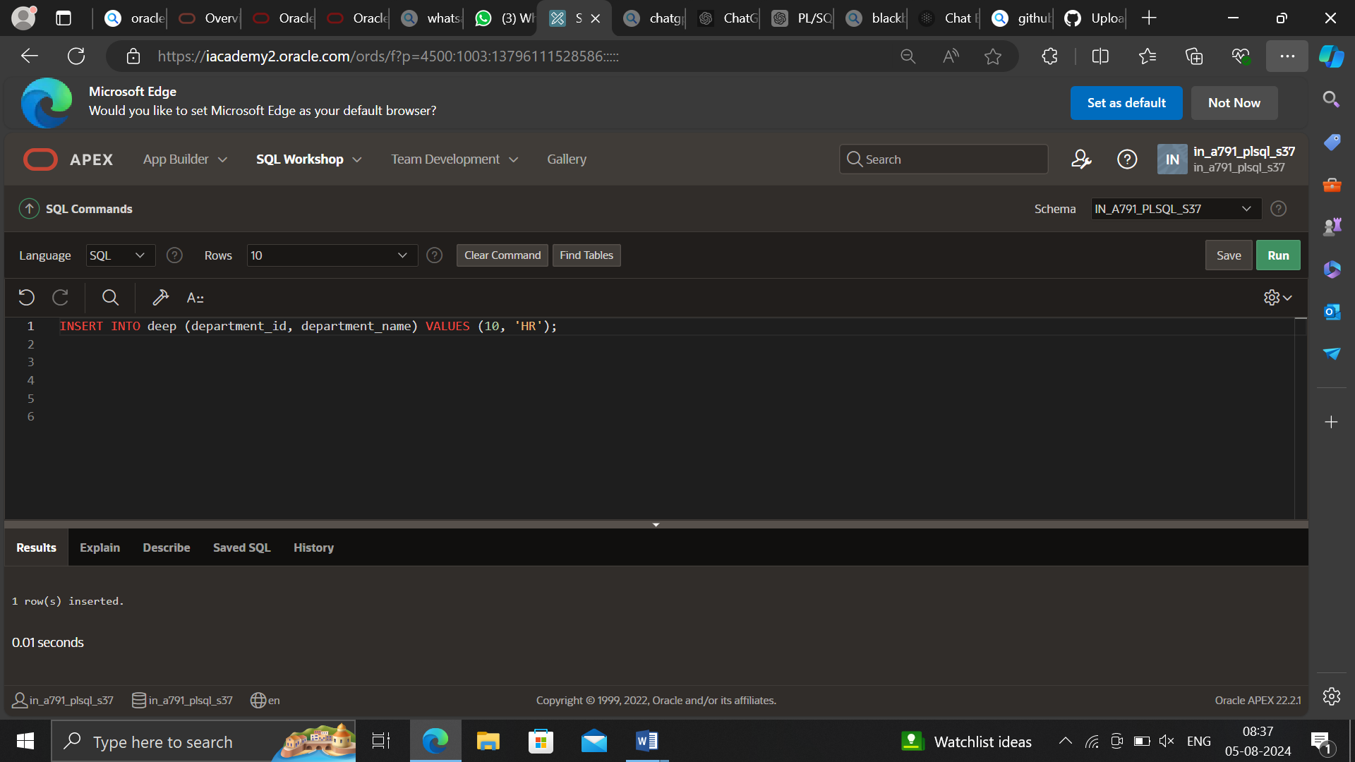

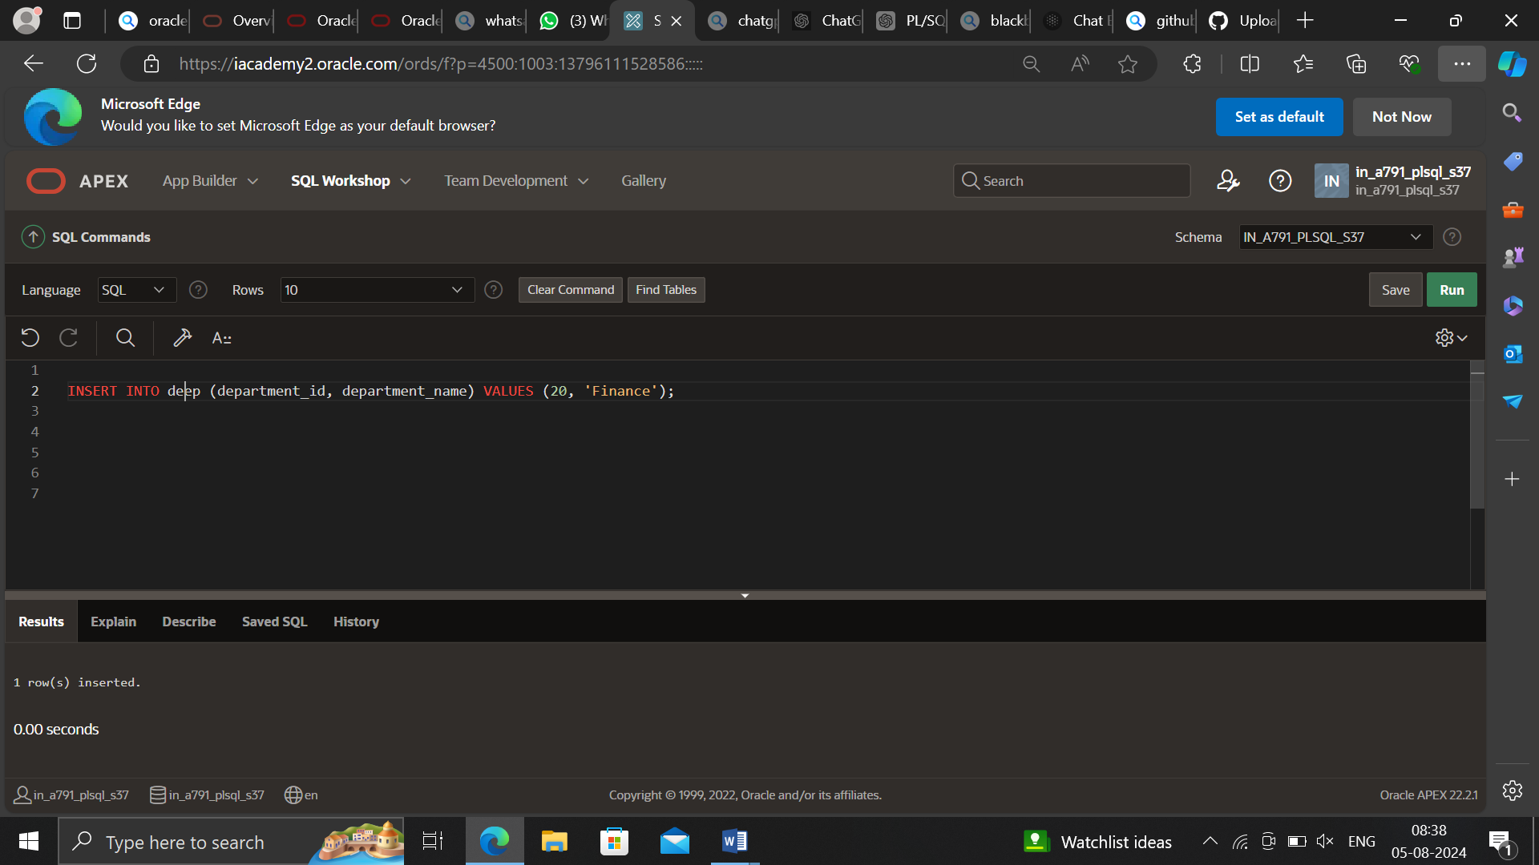

DECLARE

TYPE person_dept IS RECORD

(first_name employees.first_name%TYPE,

last_name employees.last_name%TYPE,

department_name departments.department_name%TYPE);

v_person_dept_rec person_dept;

BEGIN

SELECT e.first_name, e.last_name, d.department_name

INTO v_person_dept_rec

FROM employees e JOIN departments d

ON e.department_id = d.department_id

WHERE employee_id = 200;

DBMS_OUTPUT.PUT_LINE(v_person_dept_rec.first_name ||

' ' || v_person_dept_rec.last_name || ' is in the ' ||

v_person_dept_rec.department_name || ' department.');

END;

